**Project Plan**

**<Rentitus>**

|  |  |
| --- | --- |
| Primary Instructor | Anjana Shah |
| Team Member 1 | Abdelaziz Omar |
| Team Member 2 | Artem Elagin |
| Team Member 3 | Elham Veisouei |
| Team Member 4 | Lale Mulati |

Document Revision History

|  |  |
| --- | --- |
| Revision # | Date |
| 0.1 | Oct.7, 2022, Thursday |
| V2.0 | Feb. 3, 23, Friday |

**Table of Contents**

**1. Executive Summary**

The following describes the project to be executed.

|  |  |
| --- | --- |
| Objective | The object of this rental website is user can lend and rent home and office supplies in safe manner. |
| Corporate Goals Addressed | Our goal is to build trustworthy and reliable platform. |
| Planned Start Date | Friday, October 7, 2022 |
| Planned End Date | Friday, March 31, 2023 |

**2. Project Approvers, Reviews and Distribution List**

Approvers, reviewers and distribution list

|  |  |  |  |
| --- | --- | --- | --- |
| Project Role | Name | E-mail | Date |
| Frontend Development | Abdelaziz Omar | Abdelaziz.Omar@georgebrown.ca | Feb. 3, 23 |
| Backend Development | Artem Elagin | Artem.Elagin@georgebrown.ca | Feb. 3, 23 |
| Data Manager | Elham Veisouei | Elham.Veisouei@georgebrown.ca | Feb. 3, 23 |
| Testing Engineer | Lale Mulati | Lale.Mulati@georgebrown.ca | Feb. 3, 23 |

**3. Scope**

Define the sum total of all of its products and their requirements or features.

|  |  |
| --- | --- |
| In Scope | Out of Scope |
| Sign in | Financial Calculator |
| Post | Delivery |
| Category | Due date alarm |
| Filter |  |
| Checkout |  |
| User Profile |  |
|  |  |

**4. Deliverables**

This project will deliver the following.

|  |  |
| --- | --- |
| Deliverable | Description |
| Insurance | Out rental platform will offer third party insurance to protect users’ property. |
| Checkout | For fare trade, our platform provides international safe checkout option. |
| User profile | We provide user profile to demonstrate their credibility, reviews, and how long they participate to |
|  |  |
|  |  |

**5. Assumptions**

Our project assumptions are:

1. There might be scam hazards.

2. We must provide insurance that at least can cover up their lost minimum 50%.

3. There must be lost or missing delivery.

4. False report for their rental price to the platform.

5. Fake data.

**6. Dependencies**

The following are the internal and external dependencies that will have to be acknowledged and addressed;

**7. Risk Management**

|  |  |  |  |
| --- | --- | --- | --- |
| Potential Risk | Severity (H/M/L) | Likelihood (H/M/L) | Management Strategy |
| Scam | H | Certainly | 3rd party insurance |
| Delivery | M | Likely | Trustworthy delivery company |

**8. Communication**

**Reporting**

The following reports will be produced;

|  |  |  |
| --- | --- | --- |
| Report | Audience | Frequency |
| Scrum Master | T21 members | Every Friday 2-4 pm |

**Meetings**

The following meetings/communication will be established;

|  |  |  |  |
| --- | --- | --- | --- |
| Meeting | Purpose | Attendees | Frequency |
| On library meeting room | Discuss project process | T21 group members | Every Friday 2-4 pm |
| On Zoom | Complete project sprint | T21 group members | Every Monday 5-6 pm |

**9. Task Listing (WBS- Work Breakdown Structure)**

The following resource proposal template summarizes the resource hours committed to this project, upon final approval of this document.

|  |  |  |
| --- | --- | --- |
| Reference | Tasks | Duration |
| Sprint 1 | Frame the basic project plan. | 1 week |
| Sprint 2 | Further planning the application. | 1 week |
| Sprint 3 | Plan the details of the projects. | 1 week |
| Sprint 4 | Most important part of the project. | 2 weeks |
| Basic web app structure | Draw out the basic structure of the application. | 3 weeks |
| Sprint 5 | Documentation update; upgrade UI/UX design. | 4 weeks |

**10. Gantt Chart**

Create a detailed Gantt Chart from your Task Listing(Use any software tool and paste the image or upload as a separate file that can be opened as pdf/doc/xls)

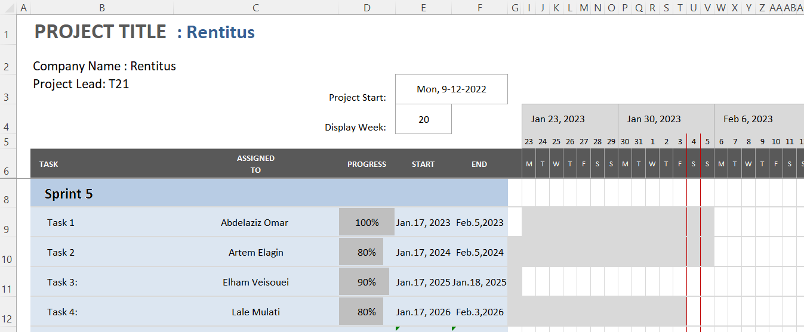

**11. Milestones**

|  |  |  |
| --- | --- | --- |
| Major Activity or Milestone | Estimated Milestone Target date | Owner/Reviewer Team Members |
| Sprint 3 | Oct 11, 2022 | Lale Mulati |
| Sprint 4 | Oct 17, 2022 | Lale Mulati |
| Sprint 5 | Feb 03, 2023 | Lale Mulati |

**12. RAM – Responsibility Assignment Matrix**

Create a RAM from your Task Listing. A sample is shown below:

|  |  |  |  |  |
| --- | --- | --- | --- | --- |
| **Task** | **Abdelaziz** | **Artem** | **Elham** | **Lale** |
| Initial project setup | P |  | S |  |
| Connecting database |  | p | S | S |
| Insurance |  | P |  | S |
| Get feedback | p |  | S |  |
| Testing |  |  |  | P |
| Set reminders, alarms | S | P | S |  |
| Transaction Setup |  | S |  |  |
| Multi language support | P | S |  | S |
| Out of scope | P | P | P | P |

**13. Approval**

The signatures below indicate their approval of the contents of this document.

|  |  |  |  |
| --- | --- | --- | --- |
| Project Role | Name | Signature | Date |
| Frontend Development | Abdelaziz Omar | Abdelaziz | Feb 3, 2023 |
| Backend Development | Artem Elagin | Artem | Feb 3, 2023 |
| Data Manager | Elham Veisouei | Elham | Feb 3, 2023 |
| Testing Engineer | Lale Mulati | Lale | Feb 3, 2023 |